|  |  |
| --- | --- |
|  | **Year 11 ATAR Human Biology**  **Task 1 – The exchange of materials** |

|  |  |  |  |
| --- | --- | --- | --- |
| **Name: MARKING KEY** | **Teacher:** | **Date:** | **Score:**  /30 |

**Assessment type:** Science Inquiry - Practical

**Conditions**

Time for the task:

* Part A: Practical activity (carried out in groups in prior lesson to Part B)
* **Part B: 50 minutes in class validation assessment**

**Task weighting** – 10%

_____________________________________________________________________________________

**Part B:** Validation

To discover how substances move into and out of cells at different temperatures, a student designed the experiment and apparatus shown below. The cellulose tubing has similar properties to a cell membrane. Starch is a long chain carbohydrate. Iodine is in an ionic solution outside the cellulose bag.

She placed one apparatus in a fridge at 4ºC and the other apparatus in a room at 25ºC

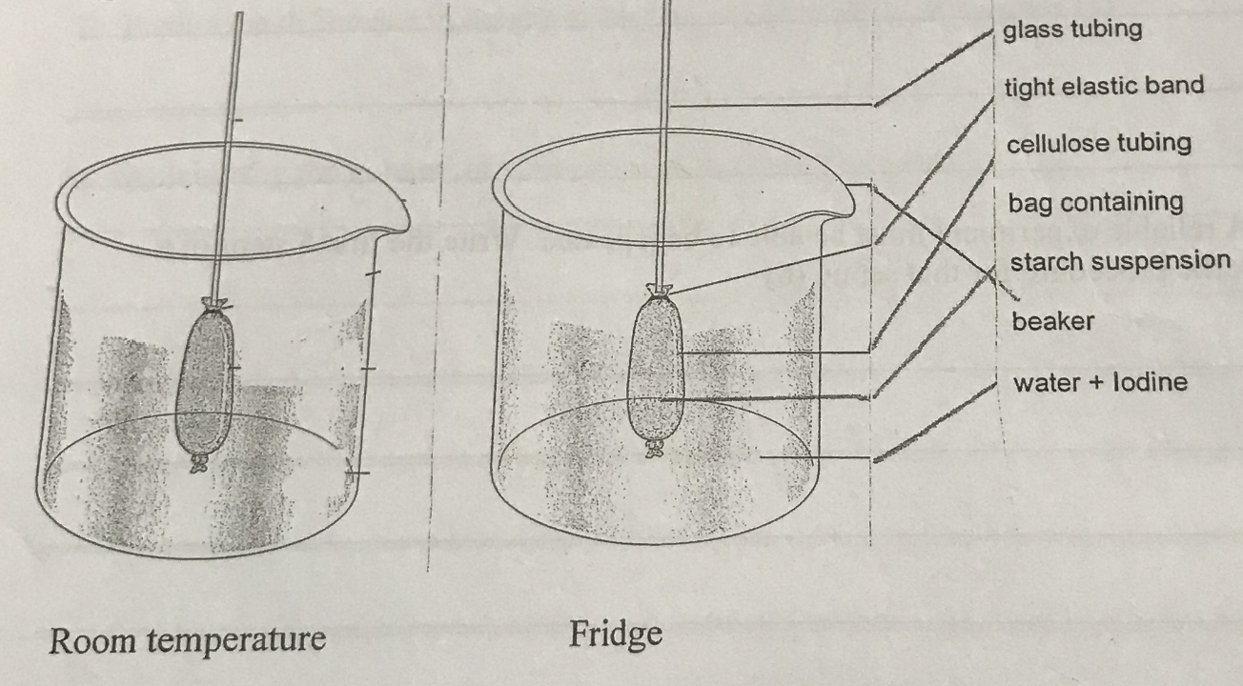

**Results Table:**

Data collected showing the height of the column of water in the capillary tube.

|  |  |  |  |  |  |
| --- | --- | --- | --- | --- | --- |
| **Temperature** | **Height of the column of water in the capillary tube (mm) at time (min)** | | | | |
|  | **0 minutes** | **4 minutes** | **8 minutes** | **12 minutes** | **16 minutes** |
| **Room (25°C)** | 0 | 22.0 | 33.0 | 38.5 | 41 |
| **Fridge (4°C)** | 0 | 12.0 | 18.0 | 21.5 | 22.5 |

1. Graph the data on the graph pape r provided. (5 marks)

Title (must include both variables) - 1

Axes labelled correctly 1

Units on labels 1

Scale correct 1

Line graph & Accuracy 1

1. State a hypothesis for the experiment.

If the temperature is reduced, then the rate of diffusion/osmosis will be slower

Must be specific and have a direction

(2 marks)

1. State the independent variable: _____Change in temperature_____________ (1 mark)
2. State the dependent variable: ____Rate of diffusion/osmosis_________________________ (1 mark)
3. List 4 controlled variables:

_______Same concentration of iodine solution__________

_______Same concentration of starch solution___________

_______Same amount of solutions/cellulose tubing_______

_______Same capillary tubing diameter_______________

(2 marks)

1. Explain why a controlled experiment is necessary.

_________To be able to compare (1) the two results and know the difference is due to the independent variable(1)________________________________________________

(2 marks)

1. Explain why the column of water rose in the capillary tube. (4 marks)

concentration of water higher outside of cellulose tubing (1)

concentration of water lower inside cellulose tubing (1)

water moves from high concentration to low concentration (1)

water level moves up out of cellulose tubing into capillary tube (1)

1. When potassium iodide solution is added to the solution **outside the cellulose bag**, it turns the water yellow but when the iodide ion comes into contact with the starch it turns blue.
2. Explain why the internal contents of the starch bag turned blue with regard to the movement of molecules. (2 marks)

Concentration of iodine higher on outside than inside of cellulose tubing (1)

Iodine molecules move from area of high concentration to area of lower concentration (1)

1. Explain why the external solution did not turn blue. (2 marks)

Starch solution molecules were too large (1) to move through the spaces in the cellulose tubing (1)

1. Given that the cellulose is a synthetic membrane. Suggest four ways that the membrane of the synthetic cellulose bag would be different from a real cell membrane. (4 marks)

not ‘fluid’ –unable to move freely no ‘bi-layer’ – not made of phospholipids not embedded with proteins unable to utilise active transport

any reasonable

1. List 6 substances that move into or out of a cell. (3 marks)

Oxygen, water, glucose, proteins (hormones, enzymes, structural),

carbon dioxide, urea, any reasonable

1. Predict what would happen if an isolated animal cell were placed in distilled water.

Explain why. (2 marks)

water would move with the concentration gradient into the animal cell (1)

animal cell would lyse (break open) due to the large increase in contents (1)

**End of Part B**